**Chapter 1: INTRODUCTION TO DATA ANALYTICS**

**Topic – 1: Chapter Overview**

* Introduction
* Data & its importance
* Data analytics & its type
* Why data analytics is important
* Data analysis v/s data analytics
* Classification of data analytics
* Elements of data analytics
* Data analyst v/s data scientist

**Topic – 2: Introduction**

**Focus Points**

* How to choose right technique?
* How to use it the right way?
* How to understand the results?

**Components Of Data Analytics**

* **Variable**
* **Measurement:** Standard process used to get **value** for a variable.
* **Data:** Records of measurements.

**Business Value**

* **Data warehouse:** Container of all gathered data by companies.
* Data warehouse helps in building **data products** & **discover data insights**.
* **Data products:** Any product that can be built using **data**.
* Data insights can help make strategic business decisions.

**Topic – 3: Data Analytics**

**Data Analytics Definition**

* It’s a process of **transforming data** into **insights**.
* Using **statistical** or **computer-based** models to gain insights.

**Data Analysis**

* Process of **examining** **& transforming** raw data in a way that it provides useful information.
* Data here are evaluated through analytical & logical reasoning.

**Data Analysis v/s Data Analytics**

|  |  |
| --- | --- |
| **Data Analysis** | **Data Analytics** |
| **Analyses happenings of the past.** | **Explores the possibilities of future.** |
| **Qualitative (intuition & analysis)** | **Quantitative (formulae & algorithms)** |

**Topic – 4: Classification Of Data Analytics**

**Types Of Analytics**

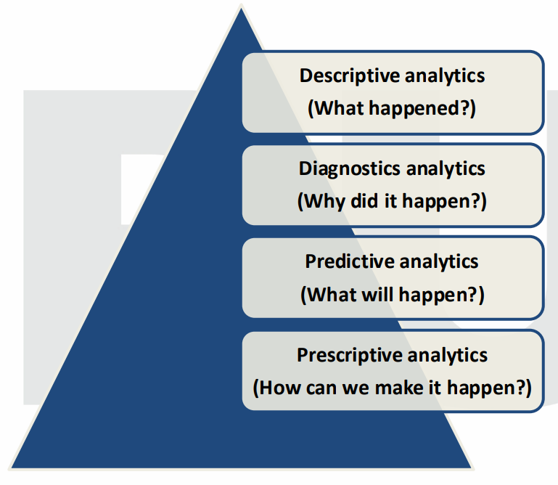

**Descriptive Analytics**

* Used in **business intelligence**.
* Provides **summary** of facts & figures in an understandable format.
* This can be the periodic **reports** or **dashboard** etc.

**Diagnostic Analytics**

* It is digging deep into an issue & finding out why it happened.
* For example, **data mining** or **correlations** etc.

**Predictive Analysis**

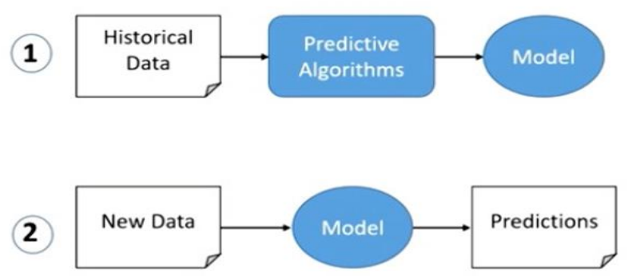

**Prescriptive Analysis**

* Tells the **best decisions** to take in order to get desired result effectively.

**Topic – 5: Data Analyst v/s Data Scientist**

|  |  |
| --- | --- |
| **Data Analyst** | **Data Scientist** |
| **Digs data to tell strategic business decisions to take.** | **Solves real-world data related problems.** |
| **Uses tools related to data mining.** | **Uses tools related to data mining & machine learning.** |
| **Cleans & transforms raw data into presentable form.** | **Builds algorithms & methods as per the insights found from data.** |